STARAGILE LINUX ASSIGNMENT -2

1. Create a file primenumberscript.sh using nano

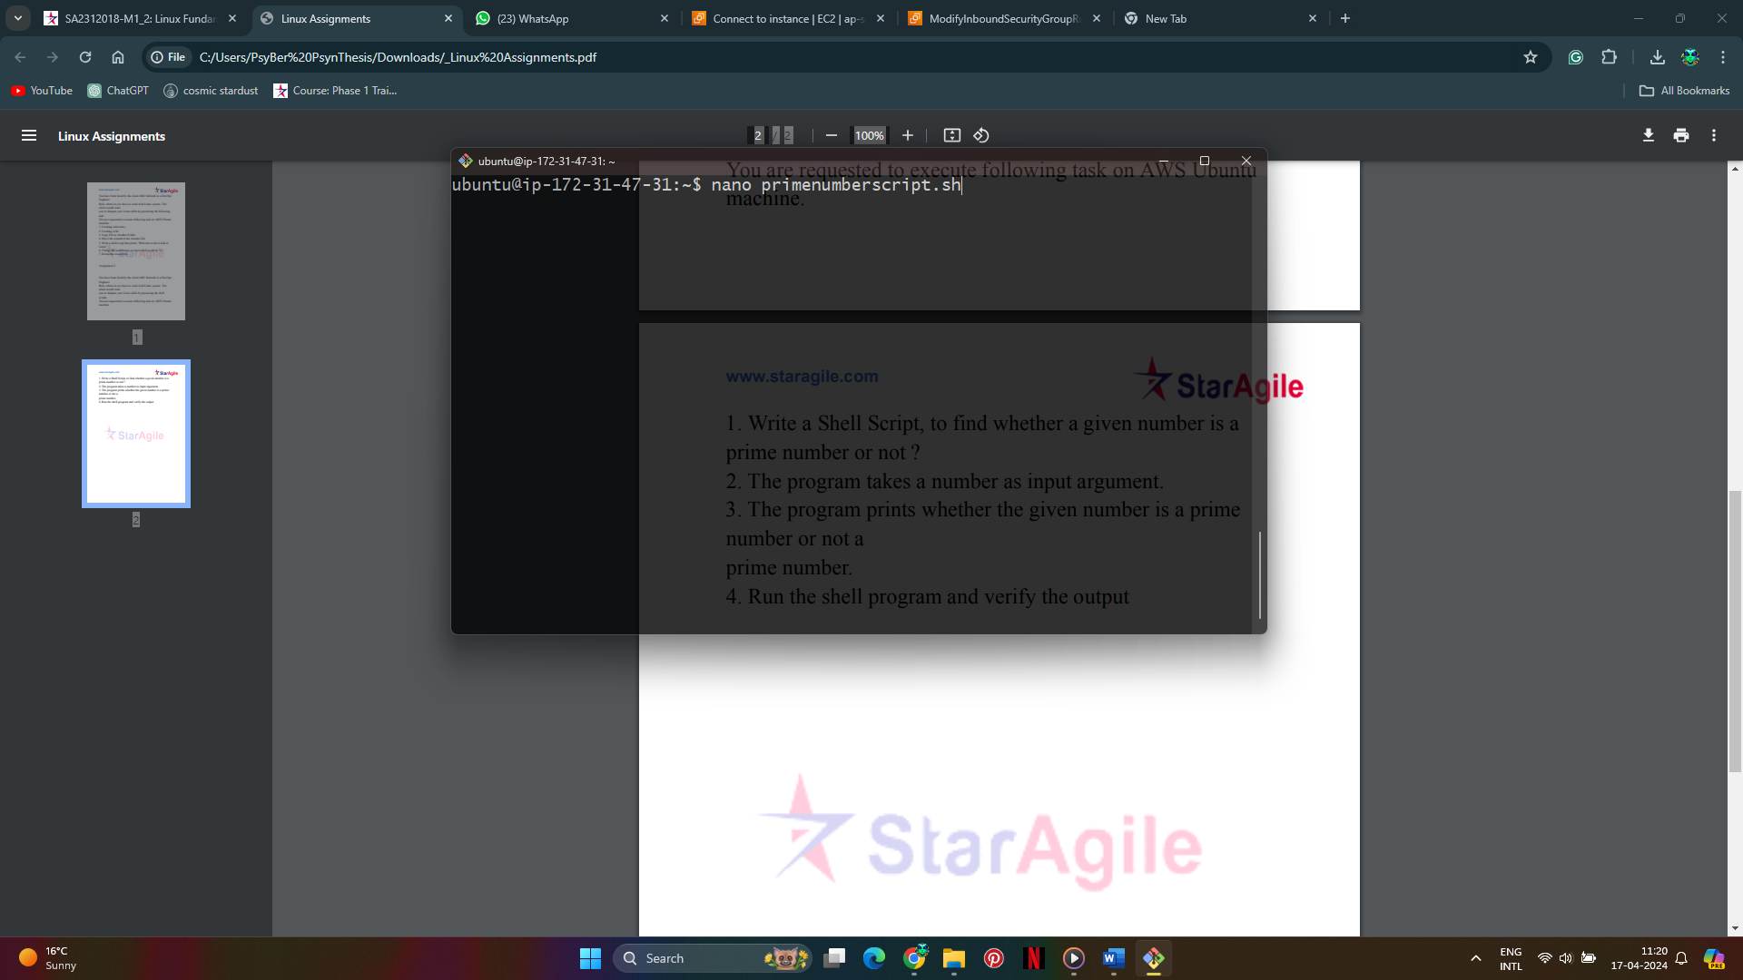

1. Write the script in bash and save it

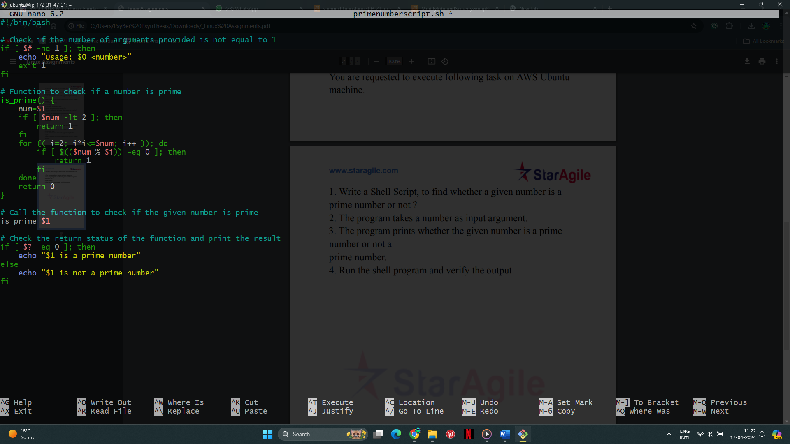

1. Change permissions

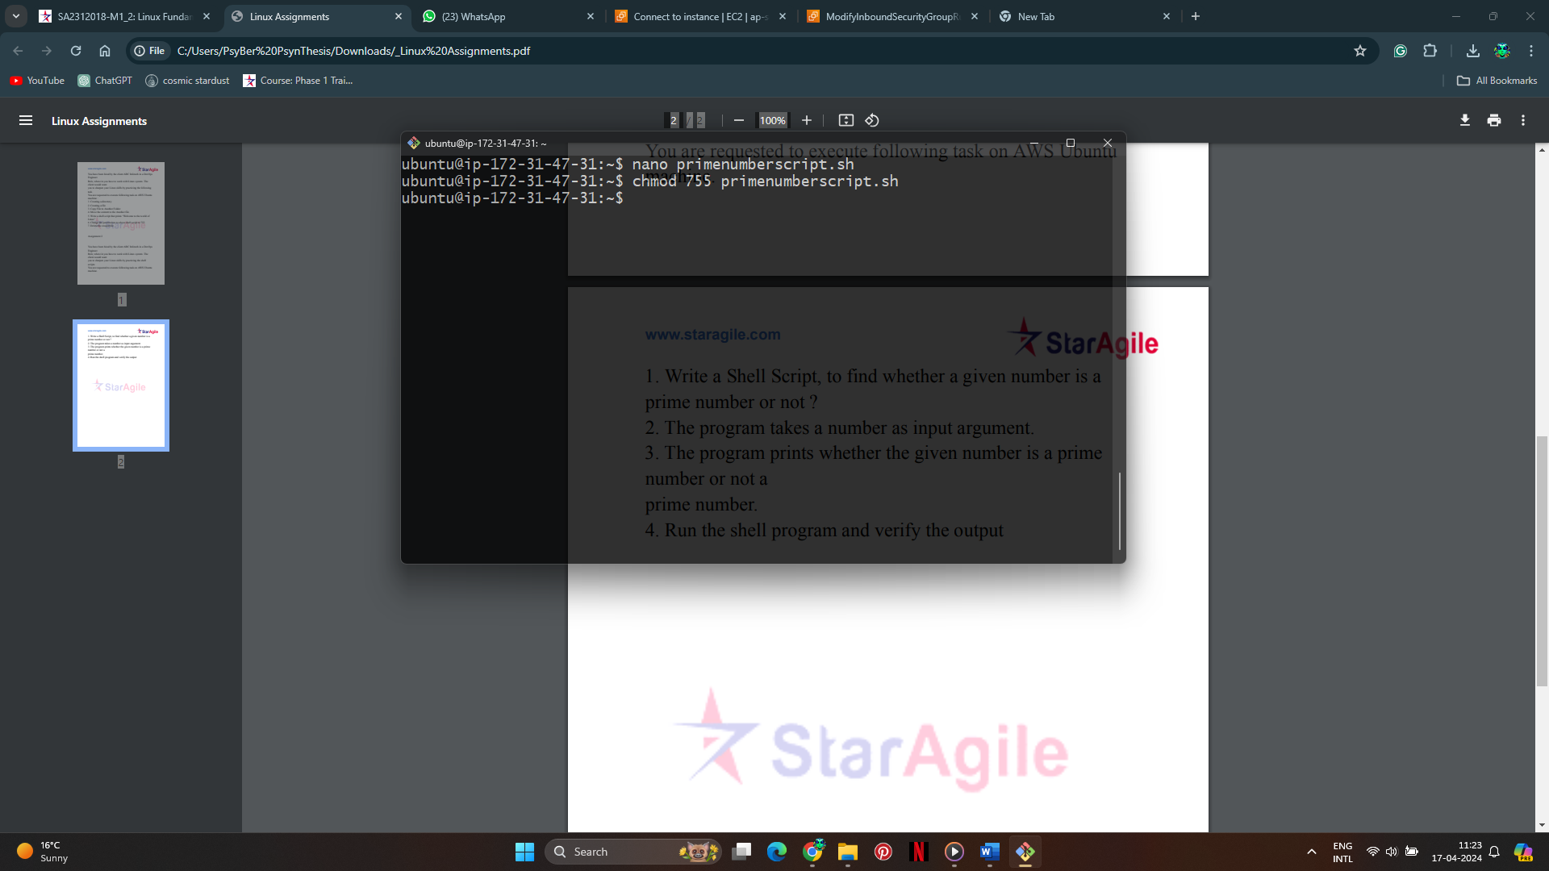

1. Run the script

